


Title



Trade Hunter

Third Year Of Computer Engineering

Authors:
Julen Gabilondo, Peru Ramos, Unai Laskurain, Andoni Usandizaga And Xabat Maortua
24th of January of 2024
Laburpena
Balore-merkatuak finantza-sistema globalen osagai kritiko gisa balio badu ere, erronka eta arazoak ditu. Iragarpen-tresna tradizionalen eraginkortasun ezak inbertsio estrategiak egokitzeko atzerapen nabarmena dakar merkatuko gertaera esanguratsuen ondoren. Inbertitzaileek informazio zaharkituarekin lan egiten dute, eta zaila da azkar egokitzea merkatuko baldintzetara. Hortaz, proiektu honen helburu nagusia balore-merkatuari buruzko web orri bat garatzea da iragarpen fidagarriak egiteko gai izango den adimen artifizialeko eredu bat sortuz. Proiektuaren nondik norakoen eta plangintzaren sarrera bat eman ondoren, proiektuaren garapen fase guztia azalduko da eta beratik ateratako ondorio nahiz etorkizuneko ildoak aurkeztu. Garatutako produktuaren efizientzia eta funtzionalitateei esker, aldagai aldakorretara egokitzea ez da arazoa izango, izan ere, etengabe eguneratzen diren datuei esker iragarpen efizienteak egiten dira eta erabiltzaileari informazio eguneratua eskaintzen zaio bilaketa bakoitzarekin.
Resumen
Aunque el mercado de valores sirve como componente crítico de los sistemas financieros globales, tiene retos y problemas. La ineficacia de los instrumentos de predicción tradicionales supone un retraso considerable en la adaptación de las estrategias de inversión tras acontecimientos significativos en el mercado. Los inversores trabajan con información obsoleta y es difícil adaptarse rápidamente a las condiciones del mercado. Por tanto, el objetivo principal de este proyecto es crear una página web con un modelo de inteligencia artificial capaz de realizar predicciones fiables sobre el mercado de valores. Una vez realizada una introducción al proyecto y su planificación, se expondrá toda la fase de desarrollo del proyecto y se presentarán las conclusiones y las líneas de futuro extraídas del mismo. Gracias a la eficiencia y funcionalidad del producto desarrollado, la adaptación a variables cambiantes no será un problema, ya que los datos que se actualizan constantemente permiten realizar predicciones eficientes y ofrecer al usuario información actualizada con cada búsqueda.
Abstract
Although the stock market serves as a critical component of global financial systems, it faces challenges and problems. The ineffectiveness of traditional prediction tools is a significant delay in adjusting investment strategies after significant market events. Investors work with outdated information, and it's hard to adapt quickly to market conditions. As a result, the main objective of this project is to develop a website with an artificial intelligence model capable of making reliable predictions about the stock market. After an introduction to the project and its planning, the entire development phase of the project will be explained, and the conclusions and future lines drawn from it will be presented. Due to the efficiency and functionality of the developed product, adaptation to changing variables will not be a problem, as constantly updated data make efficient predictions and provide up-to-date information to the user with each search.
Index
Figure index III
Table index IV
1 Introduction 1
2 Planification 3
3 Development 5
3.1 Description of the whole product 5
3.1.1 Structure of the product 5
3.1.2 Relationship between different parts 6
3.2 Artificial intelligence 7
3.2.1 Planification 7
3.2.2 Model’s development 7
3.2.3 Results 8
3.3 Web program 8
3.3.1 Server functioning 9
3.3.2 Functionalities 9
3.3.3 Systems’ connections 10
3.3.4 Structure of the web page 10
3.4 Thread simulation 12
3.4.1 Design 12
3.4.2 Synchronisation techniques 13
3.4.3 Synchronisation problems 14
3.5 Program’s validation and automation 15
3.5.1 Testing 15
3.5.2 Static analysis 16
3.5.3 Automation 16
4 Conclusions 19
4.1 Planification’s conclusions 19
4.2 Problem’s solving 19
4.3 Objectives achievements 20
4.4 SDG impact evaluation 21
5 Future lines 22
5.1 Improvements 22
5.2 Supplements 22
6 Bibliography 23
7 Annexes 24

Figure index
2-1. Figure: Initial planning's Gantt chart 4
3-1. Figure: System's architecture 5
3-2. Figure: System's connection's flow chart 10
3-3. Figure: Logged home page of the web 11
3-4. Figure: Stock market simulation page 12
3-5. Figure: Multithreading design's flow chart 14
3-6. Figure: Reusable Barrier technique's process 14
3-7. Figure: Jenkins automation's flow chart 17
3-8. Figure: Git branches strategy 17

Table index
4-1. Table: Objectives achieved and in process of achieving 20

Introduction
Investing in the stock market is a pursuit with both opportunity and risk. Statistics indicate that a substantial portion of individuals engaging in stock market investments face challenges, with approximately 98% experiencing financial losses (Sancho 2011). The complexities of market dynamics, along with the unpredictability, often result in losses for a majority of investors. Factors such as inadequate understanding of market trends, emotional decision-making, lack of diversified investments, and the inability to navigate rapid market shifts contribute to these losses. In the world of financial markets, investors often struggle with a common issue: inaccurate and slow stock predictions. Traditional methods of analysis, which heavily rely on looking at past data and using simple models, struggle to keep up with the constantly changing and uncertain nature of today's stock market. This challenge is worsened by the quick flow of information, the interconnected global financial systems and the growing impact of external factors such as geopolitical events, economic changes, and technological advancements.
The designed solution is an advanced AI-driven web system to analyse historical data about the IBEX 35 stock market along with the external factors that affect it and make predictions about the near future of the stock market. Beyond predictive capabilities, this solution also seeks to mitigate investment risks while concurrently promoting a deeper understanding of the complex stock market among users. The program is based on a network of algorithms crafted to process extensive historical market data. The project vision is to create a varied solution that not only predicts market trends but also operates as an educational tool, by empowering users with a deeper comprehension of the stock market. By doing so, the system wants to facilitate informed and strategic decision-making within the changing IBEX 35 stock market field. This approach aspires to help new stock market investors to learn how to invest, what factors they should consider and how to make decisions according to the obtained results, in order to make the most of their money.
Regarding the technologies used in the projects, HTML, Java, JavaScript, and CSS have been the most important technologies in the web page field. HTML is the main standard for the creation and design of web pages, which is a markup language used to structure the content of a web page through the use of tags and attributes (W3 Schools n.d.). The Java language is a general-purpose, object-oriented programming language designed to be portable and secure used in the backend of the project (Java TM 2023). On the other side, JavaScript and CSS are the ones that have been used in the Front-End part. JavaScript is a programming language used to add interactivity and dynamism to web pages (MDN contributors 2024) and CSS is a style language used to control the design and presentation of web pages (W3 Schools n.d.). These two define how HTML elements interact and are displayed. Regarding the AI part, it has been developed using the Python language, as it is the one that gives more options in this field. Python is a high-level, interpreted, general-purpose, and very versatile programming language (Python n.d.).
Two different servers have been developed in the backend part of the product, one for the web part and the other for the AI part. The web server is in charge of managing and offering the REST service implemented in the system, which has been developed using Java. The web server in turn uses a MySQL database to store and query all the server data (G. 2024). As for the AI server, this has been developed in Python and is an HTTP server that offers the functionalities of the artificial intelligence implemented in the project. This server is connected to an InfluxDB database where it stores and queries the data for the AI model and other data in real time (Nair 12). Another technology to be highlighted is the Node-RED tool, which is in charge of the client and frontend. All the visual parts have been developed using this tool. It is an open-source platform that provides a visual development environment for connecting devices, services, and APIs (application programming interfaces) in the context of the Internet of Things (Lea 2023). This tool has also been used for inter-system communication and integration.
To finish with the explanation of the used technologies, it is necessary to mention the use of the Google Cloud tool to upload the website to the net. A Google Cloud virtual machine has been created and through DNS the traffic to the internet has been allowed (Bigelow 2022). Apart from that, during the development part Jenkins (BasuMallick 2022) and SonarQube (Kumar 2022) tools to analyse and automate the evaluation of the source code and improve its quality.
The next part of the report will start by explaining the planning phase of the project where it will be explained how the team has been working during the project and how decisions have been made. After a description of the product, the entire product development part will be explained in detail, with emphasis on each area and field that has been worked on, including the development of the web and AI servers and, also, the automation done during all the process. Once that has been explained, the conclusions drawn from the project will be presented. Finally, an analysis will be made on the future lines that the project should follow.

Planification
Once the project itself has been explained, the planification and the methods used during the process will be explained. Regarding the methodology, the SCRUM method has been used for this project. This consists of delivering projects incrementally, that is, instead of delivering a product at the end, products are made progressively, improving as time goes by. This project has as final delivery the IBEX 35 market prediction through a web where there is also an educational part. To make the prediction it is necessary to have developed an artificial intelligence-based model, with a large dataset to ensure its correct functioning.
Each project is composed of several PBIs, which are the main tasks to be completed. In this case, the first PBIs have been focused on the WEB part. First, all the web services need to be done, followed by its functions such as login and register. In addition to that, it has been decided to make the home page of the web, as well as the historical data search part. Once the web service has been completed, the Jenkins part has been automated while the Artificial Intelligence part has to start to collect data. Continuing with the Artificial Intelligence part, the Python service needs to be created and, in the meantime, implement the scraping system. Finally, a simulation of the threads needs to be created that simulates the part in which the prediction is requested from the web. The detailed specifications of the initial planning can be found in 1. Annex: Project's initial planning.
Several meetings need to be held during the project to improve and analyse the strengths and weaknesses of each delivery. The first type of meeting is the Daily Meeting. In these types of meetings there are 3 different points. First of all, it needs to be filled with information about the details of the meeting, such as where, at what time and what day the meeting was held. Then, comes the first point which is to say what each one of the team did the previous day, as well as what they are going to do that day and the problems or blocks that they are having to continue in the project. Finally, some conclusions are taken based on the previous point, in order to summarise the meeting and the progress of the project.
Apart from that, there are other types of meetings that are done with other regularities or in just some points of the whole process. The first one of them will be the initial planning, in which all the PBIs, the initial Gantt and the product’s policies are defined. Another meeting will be the replenishment and commitment meeting, the one held each week to see if the WIP limit is correct, how the PBIs of that week will be prioritised and if new PBIs are required to achieve the desired product. The third type of meeting will be the service delivery meeting, which is done at the end of some specified phases to see how the team has been working and how the project is progressing. Finally, at the end of the project another meeting will be done to analyse the team’s performance during the whole project and make conclusions about what they can improve in future projects.
To make the product and to know what things had to be done, a Gantt chart has been made (2-1. Figure: Initial planning's Gantt chart) where it is explained what is going to be done and on what day. As it can be seen in the image, before Christmas the web has to be made with its functionalities, such as login, registration, and user editing. In addition, the team should have started with the data collection for later use in artificial intelligence and have created the python service. Also, the automation should have been done with Jenkins. After Christmas the web prediction should be done, as well as the simulation with the threads and implementation of the bot via Gmail. Finally, it will only be left to make the recommendation of the forums and the implementation of them on the website.
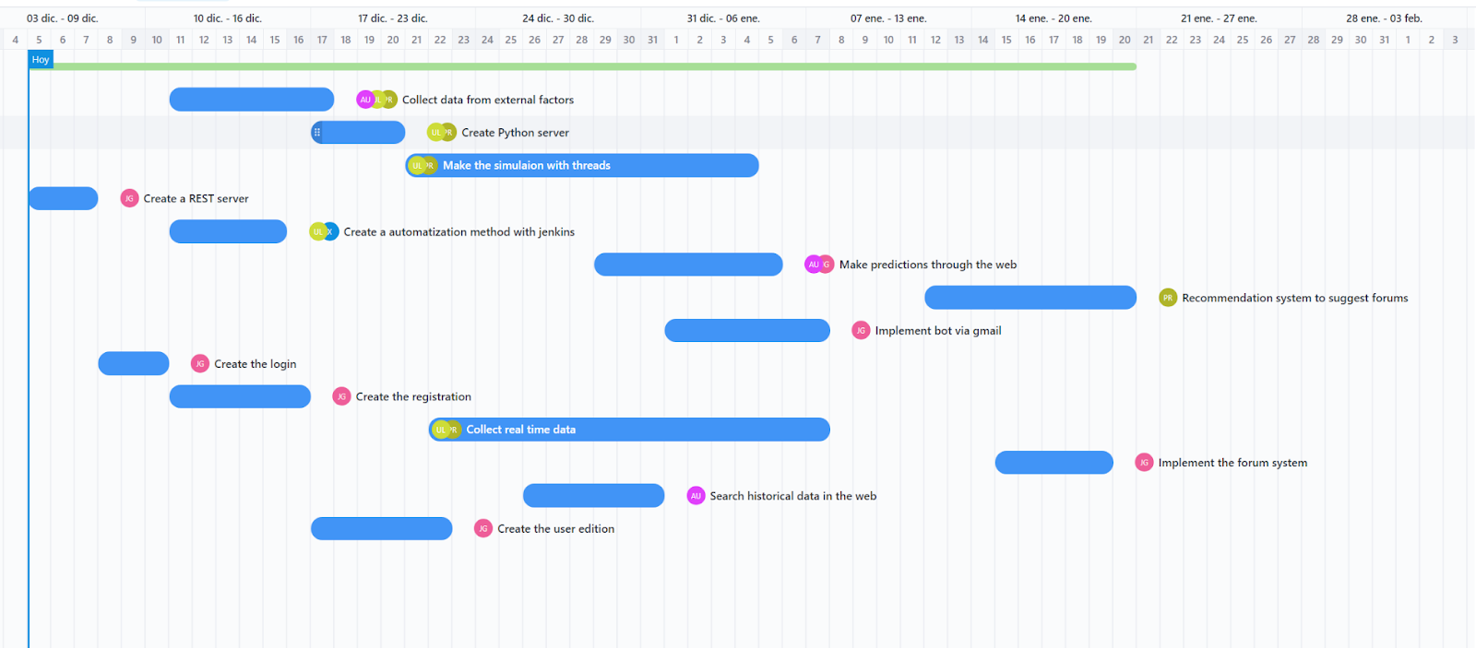
2-1. Figure: Initial planning's Gantt chart

Development
This section shall describe the development phase of the project and, after a general description of the project as a whole, shall set out the steps taken towards its implementation. To begin with, it will be explained how the artificial intelligence model have been developed to create the prediction in which the web is based. After that, it will be described how the web frontend and backend parts have been developed, also explaining how the simulation included in the web page have been designed and implemented. Finally, it will be defined the tools used during the development of all the product to test the correct functioning of the it and the automation done for it.

Description of the whole product
Before proceeding with the detailed explanations of each of the sections of this Project, an explanation of the whole Project shall first be given. To this end, it will be explained what the whole project consists of, and then explain what each part consists of and how it relates to the rest.

Structure of the product
As it can be seen in the picture below (3-1. Figure: System's architecture), application users connect to the client and interact with the web page to ask for a forecast or to look at information about different stock market movements. The website connects to the web server where all the controllers are located. This is the centre of the product, as from there it connects with the other different services to be able to do what the customer has asked for. When the client asks to make the market forecast, the notification will go from the web server to the node network and from there it will ask the python server for the prediction of the next days. To calculate this prediction, it has to take into account the data stored in the InfluxDB database, which is updated every day by the method scraping, which will be explained later in the report.
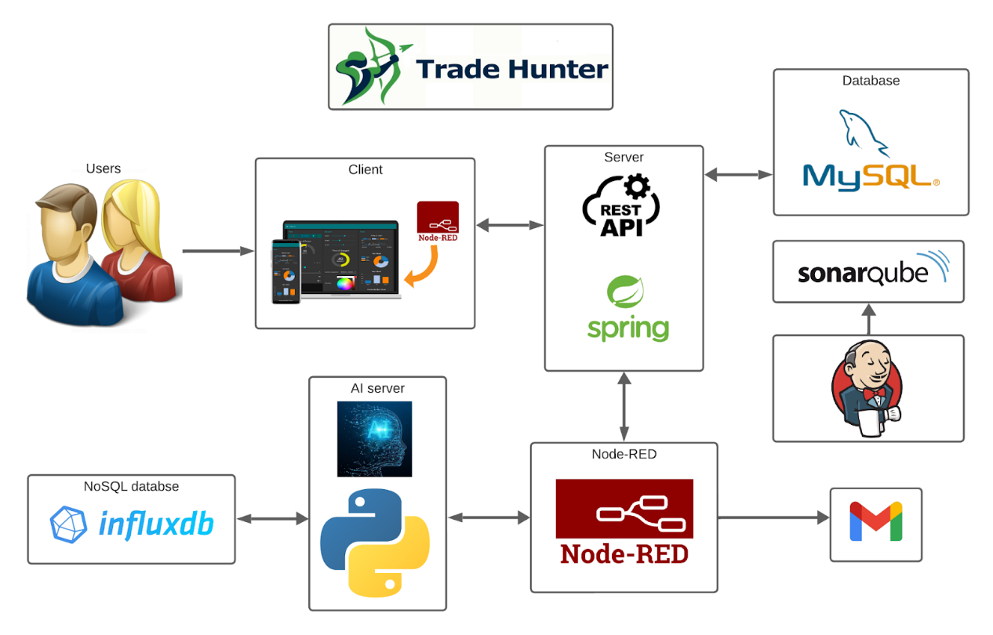
3-1. Figure: System's architecture
In addition to this, the Node-Red is also able to communicate with the user via Gmail. That is done when a new account is created, sending an email verifying the correct creation of the web, as well as when the user forgets its password and wants to change it, conducting him to a page where it can update the password. Finally, there is Jenkins, which makes the execution of the SonarQube command in an automatic way, in order to ensure that the project code is written in a proper way and that there is not any error. This is executed every time a push is done to the git repository during the whole development process.

Relationship between different parts
Once the system’s whole architecture has been explained, it will be defined the way each part of the application communicates with the rest. Regarding the artificial intelligence server, a dataset has been made in InfluxDB with external and internal factors, in addition to the latest stock market movements. This was then used to make the model. First, all the data was pre-processed, which was used to clean unnecessary data that affected other data or did not contribute anything to the model. After that, several models have been applied to see the different results given by each one of them, and, based on the results given, the one that has given the best result was chosen. That means that the one that has been closest to get the prediction right is the one that was chosen. After that, to send the prediction to the web when the user asks for it, it is given by the model in the AI server, which sends the prediction for the two following days to Node-Red to visualise it in the web page.
In the web application part, the REST server has been created, where the different controllers are placed. In this part there are the functions that the program needs to make the calls to other sites such as the python service or the node red. In addition, in the MySQL database different users have been included for the web login. Apart from that, there has also been implemented a way to register on the website by creating a new user. Then a function has been put on the website where the user can search for different data or movements from one year to another. Finally, there is the prediction, which consists of the user being able to request the prediction for that day from the website and the website provides it by consulting the information with the Python service, using Node-Red for that communication.
Apart from what it has been said about the REST server, it has also been developed a simulation with threads that simulates the real functioning of the stock market, simulating values given by external factors and giving the real prediction that it will be if those were the real values. Every time when some values are changed and the prediction is awakened, the dataset with which the model is trained is changed and a new prediction is made with new values. To do all this, the synchronisation between threads was made, giving preference to some more than others so that the program works.
Finally, during the whole development of the product, the team have been testing all the code programmed, in order to obtain a high percentage of tested coverage, both in the python serve and model part and the web program part. SonarQube has also been used to indicate the mentioned coverage, because the more coverage the code has, the more protected and secure it will be the program. Along with this tool for code’s static analysis, Jenkins tool has been used, the one that automates repetitive and continuous tasks such as building, testing, executing SonarQube and uploading executable files to the Google Cloud server. Jenkins uses the git repository to execute all the automatization every time a push is done to the repository, so that all that commands don’t need to be executed manually.

Artificial intelligence
Once that the whole product itself and the relationship between different parts have been explained, it will start the technical explanation of each one of them, starting with the artificial intelligence part. In this section, first of all, the planification of the AI model will de defined, explaining which factors have been considered for it. After that, it will be explained how the model have been developed, explaining all the process to develop it. Finally, the results obtained will be presented, in order to see how all this process contributed to the objective of creating realistic predictions.

Planification
Now in this section it will be explained the artificial intelligence part of the model. To make the different Machine Learning models that have been made, two types of data have been used: internal factors and external factors. The internal factors are those that are merely part of the IBEX. The stock market has trends, where there can be downward, upward, and even sideways trends, and it is mathematically possible to predict what will happen the next day in the stock market, just by analysing the previous values of the stock market. Those values change from day to day (as long as the stock market is open) and the exact value of each value is known when the stock market closes. The internal values used to make the model are the opening value, the highest point of the day, the lowest point, the value at the close and the adjusted close. The adjusted close is the closing price after adjustments for all applicable split and dividend distributions. In all of them the value to be measured will be the IBEX 35 points.
If the stock market were only based on mathematical trends, using only these 5 internal factors, it would be possible to achieve a model that was almost perfect, but the stock market does not only understand mathematics and trends, it is also influenced by several external factors, which are often more influential than the internal ones. The Spanish stock market will always be influenced by other stock markets, especially by the American stock market in New York, the Dow Jones stock exchange. One of the clearest examples of this is when in 2008, the American company Lehman Brothers went bankrupt, which caused the other world economies to enter into a severe recession, which later ended in the 2008 Crisis (Hernandez 2023).
Among the most important external factors that have been collected to make the model would be the internal values of the Dow Jones, which, to make a parallel with the values of the IBEX, the same internal values have been taken. But not everything is the American stock market, there are an infinite number of other external factors that influence the stock market. Among all of them, more than twenty have been taken, which have been divided into several types: economic factors, such as the Spanish GDP or public debt; social factors, such as the birth rate or death rate; and political factors, which are often a mixture of both, such as the activity and unemployment rate. To keep the model up to date, all these values are collected in real time once a day by the scrapping method, which will be explained in the model’s preprocessing part.

Model’s development
Once the factors used to make the dataset have been explained, it will be explained the process of how the model was created. In this process, several models have been used to create the artificial intelligence model. The first of them has been the Prophet model, since it is a model that is not very expensive in terms of the time it takes to calculate the model, which is very useful as the model needs to update every day.
After that, the LSTM or neural networks model has also been tested, which is a model based on time series and on retaining the information in the long term. That model gave a more accurate result, in fact too accurate, since the prediction was exactly the same as the market. This was too realistic, so, after analysing and testing the model, it was discovered that when the model was asked to predict the closing price of the next candle and it was provided with the closing price of the current candle, the model will learn that the next closing price would not be that far off the current closing price. In other words, any predicted value that is provided by the model that is close enough to current day’s closing price is going to look like a good value. This is why it was decided to use the Prophet's model instead.
To build the model after making all the dataset, it has to be put in the python document that collects the data from the excel by putting the path. Then, to know if the dataset has been loaded correctly, the data will be painted. Once that is done, the data will be divided into two columns. One of them will be the numerical columns and the other one will be the categorical. That is done so that later the missing data that can be throughout the dataset can be correctly handled. That is to say, there are dates that do not have data, which means that there are empty values. To avoid that, what has been done was to apply the average to all the values that are in the dataset and to put those values in the missing dates.
Afterwards, in the pre-processing part correlation between the different variables was looked at, and, if any obvious correlation was seen, one of the dependent variables was eliminated, because in this way unnecessary information that the model has to process was saved. Once this is done, the information in a graph that represents all the information is seen, so that the different movements of the stock market can be seen. This information can be sorted by weeks, days and even years. In addition to this, other types of graphs will be also used to see the information in other ways and to analyse it in a proper way.

Results
After having the information processed, the information is separated into data for training the model and data for testing it. As the prediction is made for two days to train the data, the whole dataset will be used, except from the last two days, because those will be used for testing. Once this is done, the names of some columns are changed, specifically the index, which is the date and the target that is the value that indicates the value at which the market changes that day. The prophet model is then trained to make the prediction about those two days values.
Once the prediction is done, the result will be looked at and compared with the real results to know how good the result is. In this type of project, it is somehow difficult to predict what is going to happen in the market, but the important thing is to obtain a result more or less similar to what it is in reality. To do this, the real data will be plotted against the data that has been obtained and see how much difference there is between them. In this case it is

Web program
After explaining the artificial intelligence model and the results obtained, it will be explained the web program that is responsible for showing the results in the web page. In this section, firstly, it will be explained how the REST server works and the functionality that this one fulfils. Then, how the connection between systems using Node-Red is done will be defined and, lastly, it will be presented the different pages that the web page is composed of, explaining the different functionalities that are available in each one of them.

Server functioning
To create the internal logic, the backend of the website, two different web servers have been used: a Java REST server, and another Python server for the artificial intelligence part and everything related to massive and real-time data. This section of the document will explain the Java REST server. This web service has been used mainly for user requests related to the MySQL database. In that database, the user's personal data, such as the user’s information or the messages that different users of the platform have sent, have been stored. The created web server works as follows: when a user makes a request related to his personal information to the web page, that request goes directly to a REST controller. That controller will do the necessary business logic to satisfy the user's requests and send a response to the user. This web server is located in a Cloud server, which, through a DNS, has joined with an internet domain, so that all requests made to that domain go directly to the server.
To make all the main structure of the web server, JPA has been used. JPA is an API, which provides a mechanism for managing persistence and object-relational mapping. It is used to map the objects in the JAVA classes and then to create the tables in the MySQL database (it can be any type of database, as long as it is a relational database) with the correct relationships between the entities. To do this mapping, it is necessary to define in the Java classes, the types of relationships that the classes have between them. This definition is done using the @ManyToMany, @ManyToOne and @OneToMany tags. By using these tags, it can be specified which is the parent and which is the child, as well as define the relationships correctly. In addition, the JPA API brings with it an internal facility for making requests to the database. Using a JPA repository, CRUD functions can be made from the database without having to do anything more than create a repository for each entity (Java classes).

Functionalities
After explaining the server's functions, the functionalities of this server will be explained. CRUD methods, an acronym that stands for Create, Read, Update and Delete, are fundamental operations in database management systems and applications. The "Create" function (POST function) is used to add new records, such as users or messages. On the other hand, the "Read" method (GET function) is used to retrieve stored information for viewing or analysis. The "Update" operation (PUT function) is used to modify existing data, such as updating the address of a client. Finally, the "Delete" method (DELETE function) is used to delete specific records, removing associated information, such as the removal of a product from inventory. These methods are essential for effective data management, providing the tools necessary to manipulate information in a comprehensive and consistent manner.
Each controller has been programmed to be able to receive and send data in XML and JSON. These are commonly used data interchange formats in programming. When a controller receives a request, if that request is accompanied by data, it must be in the form of XML or JSON. Once the controller does all the business logic that the user has asked it to do (CRUD functions), it will return the information in the format that the user has requested in the request. In the Java classes that have to be mapped to XML or JSON, a schema has been made for each of them, so that the Java-XML or Java-JSON mapping is done correctly. In JSON and XML, a schema is a set of rules that defines the structure and type of data in a document. It serves to validate and standardise the representation of information, facilitating communication between systems. In XML, XML Schema is used, while JSON Schema is used in JSON.
In the web server, different controllers have been made that use different CRUD methods and return different types of information. One of the clearest examples of the use of the GET method is the "getMessages" function. This function receives the ID of a forum as a request variable and returns all messages from that forum. In the "register" function, the POST method is used to create a new user. The PUT method is used in the "editUser" function to update the user information and finally the DELETE method is used in the "deleteUser" function to delete the user.

Systems’ connections
In this project, as mentioned earlier, the Node-RED application has been used. Node-RED is a visual programming platform that facilitates the integration and automation of data flows between different devices and services through the use of interconnected nodes. Effectively, it has been used to connect different services and make an interactive website out of it. HTTP nodes have been used to connect Node-RED with REST and AI server drivers, which are based on calling a function that manipulates the database (MySQL with Java and InfluxDB with Python) and returns values, objects, or lists to show an interactive and attractive interface to the user.
JSON and XML formats have been mainly used to send and receive data with Node-RED, as it is capable of handling these types of formats. To send them, HTTP nodes have been used to make connections with the other services. This data sending has been done mostly to store and receive data in the InfluxDB or MySQL databases. The data sent contains all the information that the other system needs to perform, which makes it possible to have several basic functionalities such as a register of users, data, messages, among many others. All the flow described can be seen in the image below (3-2. Figure: System's connection's flow chart).
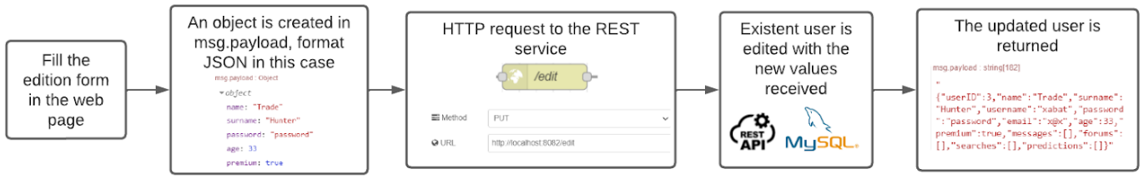
3-2. Figure: System's connection's flow chart

Structure of the web page
Once the connection between the systems has been explained, it will be explained which is the structure of the web page and the pages twitch the web is composed of. As it has been said before, the Node-RED Dashboard has been used in this project to implement an intuitive and interactive graphical interface. Before mentioning the pages that are in Trade Hunter, it is necessary to note that the change of screens is done by specifying the name of the next page in the variable “msg.payload”, which is the most used in Node-RED, and a node called “ui_control” manages it, changing the current one with the screen with the specified name. The application consists of several pages to offer the user various functions and services.
The first screen is the welcome screen. In this screen, the user will see a welcome message with the Trade Hunter logo and a button to start. If this button is clicked, the current page will be the register page. Here, new users will be able to register in Trade Hunter. Once the account is created, the new user will receive a welcome email, and will be able to log in via the login page. Here, there will be a simple form to insert the username and password. In addition, if the user has forgotten the password, he will have a button that will take him to a page to insert his email and will receive a message to recover his account by changing the password.
Once the user has logged in to Trade Hunter, a home page will be presented. On this page, he will be able to see his details and the option to change them in the left corner, and the functionalities offered by the application on the right side of the screen, with a brief description. The aspect of the page can be seen in the image below (3-3. Figure: Logged home page of the web). As mentioned, the user will be able to change most of his data on the edit user page through a form. One of the characteristics that the app offers is the prediction of the index of the stock market on the next day. In the predict page, the user will be able to, as the name says, see the prediction of the index, by clicking on a button. Trade Hunter will automatically show the index of the next day, with a graphical representation.
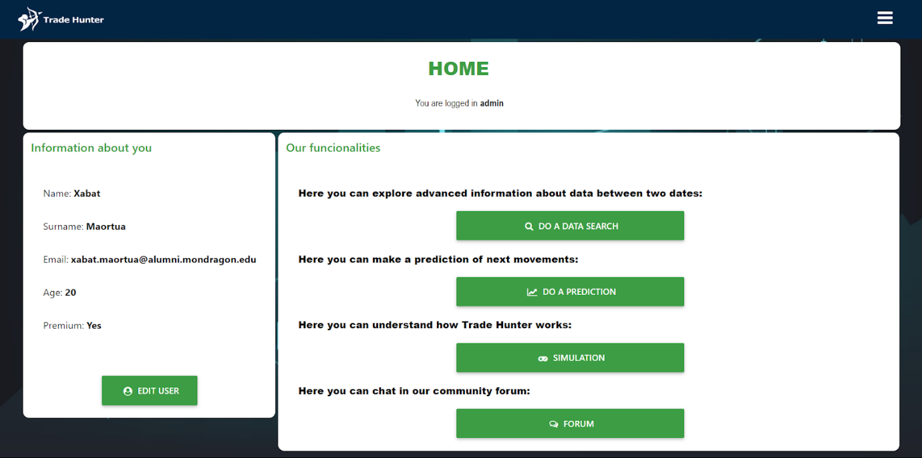
3-3. Figure: Logged home page of the web
As one of the objectives of Trade Hunter is to provide knowledge about the stock market to the users, a page in which data searches can be performed has been created. Here, the user will be able to search data values in a range of time. A table and a graph with the internal values of IBEX of this range will be shown. Furthermore, some of the external values that affect the index will be displayed with the corresponding graph and explanation so that the user can understand and know how and why each variable affects the index. Another way for the user to learn about the stock market is by chatting, asking questions, or seeking advice from other people, and for that the forum page has been created. On this page, the user will be able to chat in real time with other users from Trade Hunter.
Lastly, to understand the working of Trade Hunter, a simulation page has been created, where the user will be able to see how the prediction is made using simulated data, in order to see how well the prediction responds to the changing data. In this page, the user can run a simulation where external factors values change in real time and, as a result of these changes, the stock market index prediction graph will be changing as time goes by. The user will be able to stop the simulation and restart the graphs to initial value in order to start another simulation. In the image below the aspect of this page can be seen (3-4. Figure: Stock market simulation page).
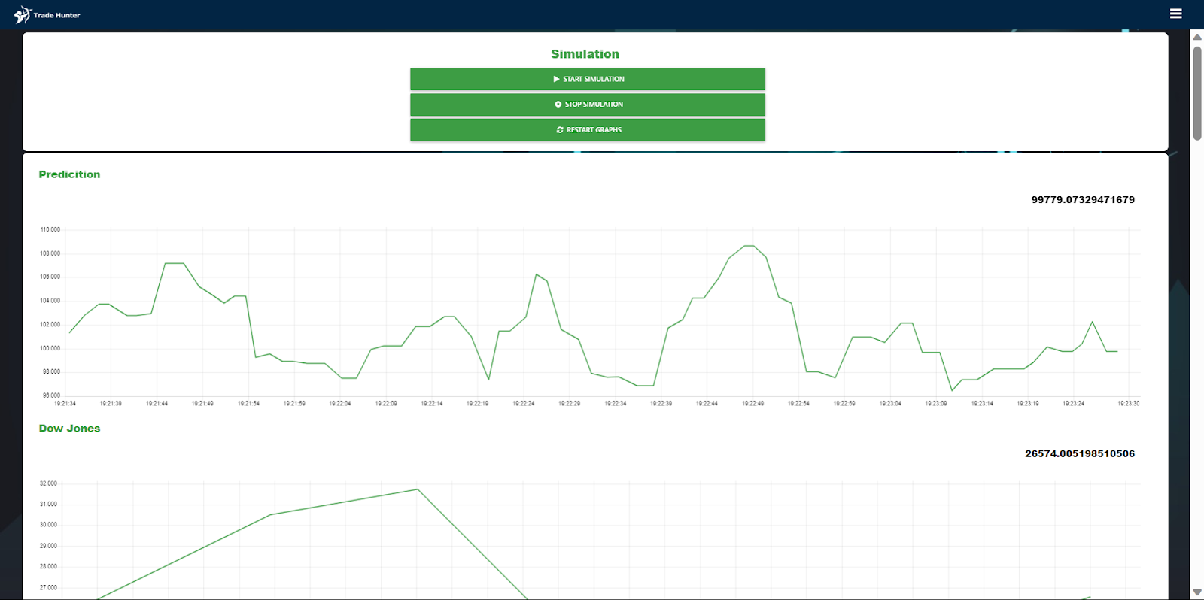
3-4. Figure: Stock market simulation page

Thread simulation
Even if the web program has been described, there is a major functionality on it that has to be explained. That functionality is the thread-based simulation, in which users will be able to simulate the real functioning of the stock market in order to see how the prediction model works based on the external factors. In this section, to begin with, it will be explained the design of this simulation, explaining the different thread that this is composed of. After that, it will be explained the synchronisation techniques that have been used in the development of this simulation. Finally, some synchronisation problems that were found during the development of this will be explained, as well as the solution that have been given to each one of them.

Design
As for the project’s Multithreading design, it applies to the simulation part for any user on the website, as anyone who visits the website that is logged in can run this simulation. Multithreading simulation, using test data, simulates a real system prediction and makes it visible to the user with a graph. To do this, the multithreading structure had to be designed, because it was considered to provide many different opportunities for a simulation, but not all of them aim at the objective of simulating real stock market functioning correctly.
To make a prediction, different threads are created in the multithreading system. Each thread simulates over time the value of a factor by which a prediction is made. First of all, an individual thread called the Dow Jones is produced in the system, as its name suggests, which encompasses the values of the American Dow Jones stock market over time. Other threads that arise are threads that simulate social, political, and economic factors. As far as social factors are concerned, they are threads that simulate both birth and death rates and per capita debt. The political factors simulated by threads are the active population, the employment, and the unemployment rates. The threads that simulate economic factors are CPI (Consumer Price Index), euro value, euribor rate, debt and GDP (Gross Domestic Product). Besides this, there is also in the simulation a thread called “Prediction”, which is responsible for reading the given values and making a prediction based on them.
Another significant thread that’s part of this multithreading design is the “ValueSender” thread. Throughout the simulation, a number of messages are sent to this thread, which manages these messages using the message passing technique. In the context of programming execution threads, message passing is a communication technique between threads, exchanging messages. When there are multiple threads running in parallel in a program, it is necessary to communicate with each other to coordinate tasks, share data, or synchronise execution. Every time a thread sends a message, the “ValueSender” thread places these messages in a waiting row. After a while, from time to time it picks up these messages and then sends them to the Node-RED tool to draw the graph with these values.

Synchronisation techniques
In this simulation, two different multithreading models have been implemented. In the first model, the original Prediction thread is the most important one. All of them want to call the “Prediction” thread, so a model that manages it has been developed to achieve better efficiency. The importance of each thread comes into play here, as the Dow Jones will be able to make a prediction every time it gives the value. It must be said that this is the one that waits the most when it comes to giving it a new value. As for the threads that simulate economic factors, when three of them give a value, they will be able to make a prediction. With the threads which simulate political and social factors, a special situation is given. These three political and social factors will be able to make a prediction when three of them have been given, but there are several ways in which this can happen. It is possible that three socials of three politicals by themselves make a prediction, but also to make it when they are two socials and one political or one social and two political.
The “Prediction” thread will wait until a previously explained case is given, when the thread will go on and make a prediction. This is where semaphores come into play. A semaphore is a synchronisation tool used in concurrent programming and operating systems to control access to a shared resource through multiple processes or threads. A semaphore has two main methods: release and acquire. The release method increases the value of the permits of semaphores, which indicates the usefulness of a resource, while the acquire operation reduces the value of the semaphore’s permits. If there are no permits left, it would block the thread, indicating that a process or thread is requesting a permit to go on. These operations allow for synchronisation and effective coordination.
To understand better the functioning of this technique, an example will be provided. When the program starts if an economic factor gives a value, this thread stops at a semaphore waiting for a casualty to make a prediction, which can be 3 economical, 2 economic and 1 social or 1 economic and 2 socials. After one of two cases happen, the prediction thread is awoken and makes a prediction based on the values given, and this thread awakes those threads and waits for them to add those values to the message to send. After the name of the thread and its value being added to a waiting list of what needs to be printed on Node-Red, the prediction thread is again awakened to add its own value to the list. Finally, the prediction thread sends the list to the ValueSender mentioned at the beginning, and all the threads that were waiting can continue working as before, while ValueSender sends the message to Node-Red to print the changes. In the image below the synchronisation between the threads can be seen (3-3. Figure: Multithreading design's flow chart).
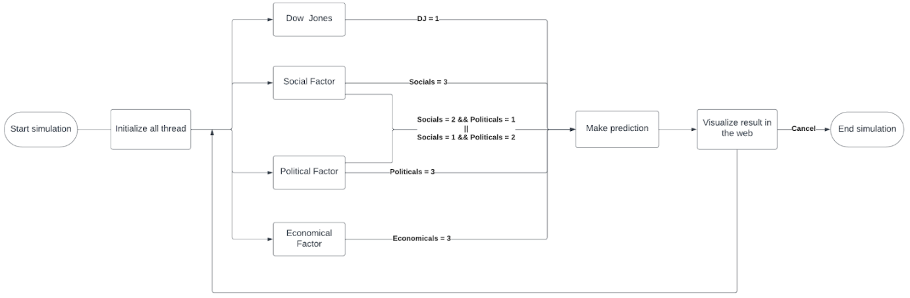
3-5. Figure: Multithreading design's flow chart
The other model mentioned above serves to exploit behaviour between strings that simulate social and political factors. As has already been mentioned, special casuistics may be given between social and political factors when making a prediction. This model is used to control all these situations. The Reusable Barrier technique has been used for this purpose, which uses semaphores to allow a group of wires to be synchronised together, so that they can be reused for multiple cycles. This kind of barrier allows social factors to wait for political factors, or a political one to wait for a social one. Once these are joined together, this barrier lets them pass until they are all passed, then it closes and lets the threads which were previously waiting at the beginning of the barrier pass to make the mechanism useful again. In the image below the functioning of the barrier can be seen (3-4. Figure: Reusable Barrier technique's process).
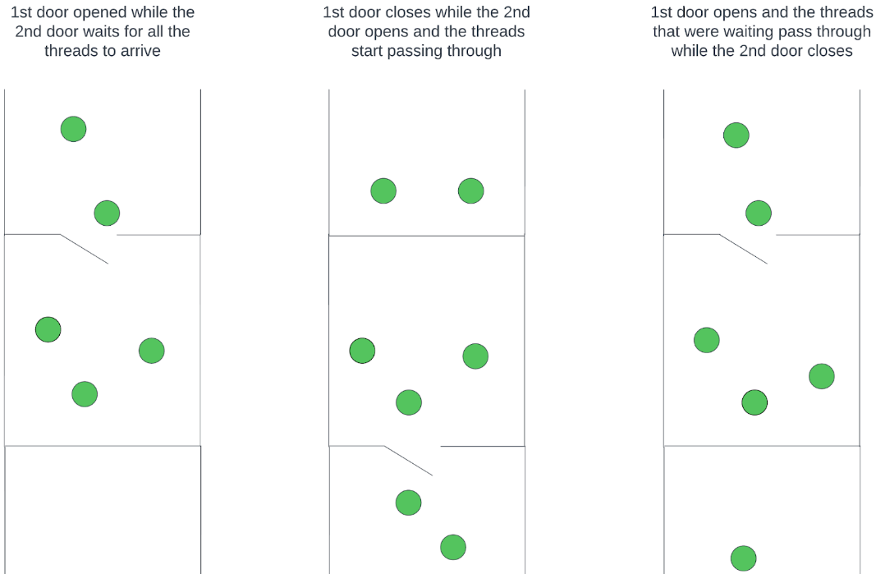
3-6. Figure: Reusable Barrier technique's process

Synchronisation problems
Once the simulation design has been explained, it will be explained some synchronisation problems that were in the development of this multithreading design. The first problem of synchronisation occurred in establishing all the leading roles in the prediction thread. When a prediction can be made, this thread must have preference. To this end, a function called getMutex has been developed to manage the mutex semaphore. The purpose of a mutex is to ensure that a single thread can simultaneously access the protected resource, avoiding race conditions and incompatibilities of data. If a prediction is in process, this function has been used to apply the need for a thread to release the mutex in acquire, and to wait for it again. This gives priority to the predictive thread when necessary, solving the problem of synchronisation.
Another problem of synchronisation that arose when this simulation system was implemented was knowing how many political and social factors were to be drawn in a prediction. To solve this synchronisation problem, two other variables were created in the program, “SocialToPaint” and “PoliticalToPaint”. These variables contain the number of political and social factors that need to be drawn up in the graph, so that everything is then clear at the time of drawing, and this is not stored in the nSocial and nPolitical variables of the system, thus overcoming the synchronisation problems that this caused.
To put an end to these problems, without interrupting the process of drawing the graph to Node-Red, there was a need throughout the project to find a way to send the data to it without stopping all the program. To this end, the several times mentioned ValueSender thread has been created. As it was said, using the message passing technique, it passes the messages to a waiting line and picks up these novices and passes them to Node-Red. This is executed in parallel, so that the multithreading program continues working, unless it reaches the limit of 3 simultaneous threads in the list, where the program would have to wait until one of those messages have been sent.

Program’s validation and automation
Once all the servers the product is based on and the simulation in the REST server have been described, it will be explained the program’s validation and automation that was done during the whole process. First of all, how the programs’ testing was done will be explained, in order to ensure the correct functioning of the product. Later, it will be described how the static analysis of the program was done, as well as present the results obtained. To finish, it will be defined the process made to automate all the testing and static analysis of the product, in order not to do all this process manually.

Testing
During the development and maintenance of artificial intelligence and web servers, tests play a crucial role. They are mainly used to verify the correct functioning of the various units that make up the system. These tests include unit tests, which focus on individual components to make sure they work as expected, and integration tests, which verify how these units interact with each other. The goal is to ensure that each part of the system meets its specifications and works harmoniously with the others, thus reducing the likelihood of errors and failures in the production environment. Furthermore, these tests have verified the performance of the parts of the system in all kinds of situations to make them as consistent as possible.
JUnit 5 has been used for the web service, developed in Java. JUnit 5 allows unit and integration tests to be carried out in an efficient and structured way. Tests are performed for each developed function, and, through the use of assertions, the definition of test conditions and the verification of the expected results are facilitated. On the other hand, the use of mocks has been essential in this project. Mocks are objects that simulate the behaviour of real system components but are controlled by the test environment. Thanks to this, it is possible to test the correct performance of the functions without having to rely on other elements to do so. In this way, tests can be performed in an isolated and controlled way, in order to identify possible errors and test the function in different situations.

Static analysis
For the analysis of the developed code, SonarQube is the tool that has been used. SonarQube is an open-source platform used to continuously assess source code quality and detect security vulnerabilities. It provides an automatic review with detailed reports on bugs, code issues, technical debts and coding standards, thus facilitating the improvement and maintenance of software quality. In this project, SonarQube has been used to scan both the Java code of the Rest Server and the Python code of the AI server. Thanks to this, a good programming practice has been achieved, reducing the amount of code smells, and eliminating possible bugs and code problems. In addition, with this tool and the tests, it has been possible to observe the amount of code that has been tested, and, in this way, nothing has been left unchecked.
SonarQube evaluates several key parameters to ensure code quality and security. First, there is the coverage of the code, which measures the percentage of source code that has been covered by automated tests, being the final value obtained [VALOR COVERAGE FINAL]. Second, there is the cyclomatic complexity, which evaluates the complexity of the code to identify possible maintenance difficulties. A high value may indicate that the code is too complex and therefore difficult to understand and maintain, and in this project the value was [VALOR CC FINAL]. Third, there is the bug parameter. This one shows the detected potential errors in the code, preventing malfunctions, and the value was 0. Another one, is the value of code smells in the code. SonarQube shows the number of identified problematic patterns in the design that can complicate maintenance, and it has been achieved the value of [VALOR CODE SMELLS FINAL]. Last but not least, there is the vulnerability quantity. SonarQube finds weaknesses that could be exploited in security attacks, which has to be 0, as in the program developed.

Automation
The process mentioned above has been automated using Jenkins. Jenkins is an open-source automation server used to facilitate continuous integration and continuous delivery (CI/CD) in software development, enabling the automation of tasks such as build, test and deployment. In this project, every time a push is made to the remote repository, a Jenkins pipeline is executed. This pipeline allows to perform certain tasks automatically. First of all, it builds the project that is being uploaded and then, it runs all the existing tests and makes sure that they are well executed. Once this is done, it also automates the scanning of SonarQube to always keep the parameters mentioned above in mind. Finally, if the push is to the master branch, which is the final branch, where the final product is, it creates a .jar file that automatically uploads to the virtual machine hosted in Google Cloud, which is used to execute the REST server. All this process can be seen in the image below (3-3. Figure: Jenkins automation's flow chart).
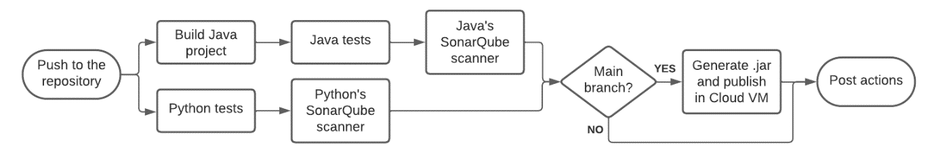
3-7. Figure: Jenkins automation's flow chart
As mentioned above, a Debian 11 virtual machine hosted on Google Cloud has been configured for this project. The main purpose of this is to have all the tools available to the project members, which brings several advantages. Thanks to having all the applications configured in this virtual machine, the Jenkins automation process can be executed with the pushes of all the members, not only with the one that has the local configuration, since the code is the one recently updated in the repository. In the same way with SonarQube, the most recent code in the repository is scanned, instead of scanning a local project, thus speeding up the task a lot.
To maintain order in the handling of the remote repository, the team has organised the handling of the branches. During this project, 5 branches have been used: main (master), develop, feature, release, and hotfix, having each one of them its own function. In the master branch, the final product, deliverable to the customer, is located. The develop branch, as the name suggests, contains the version that is being developed and updated by the next branch, and with the feature branch new functionalities are added to the product. Once a deliverable product is in hand, the release branch comes into action, which is used to make the final adjustments before merging with the main branch. Finally, the hotfix branch is used to fix errors or bugs that have arisen in the final product. In this image it is visible the branch management that has been carried out during the project (3-4. Figure: Git branches strategy).
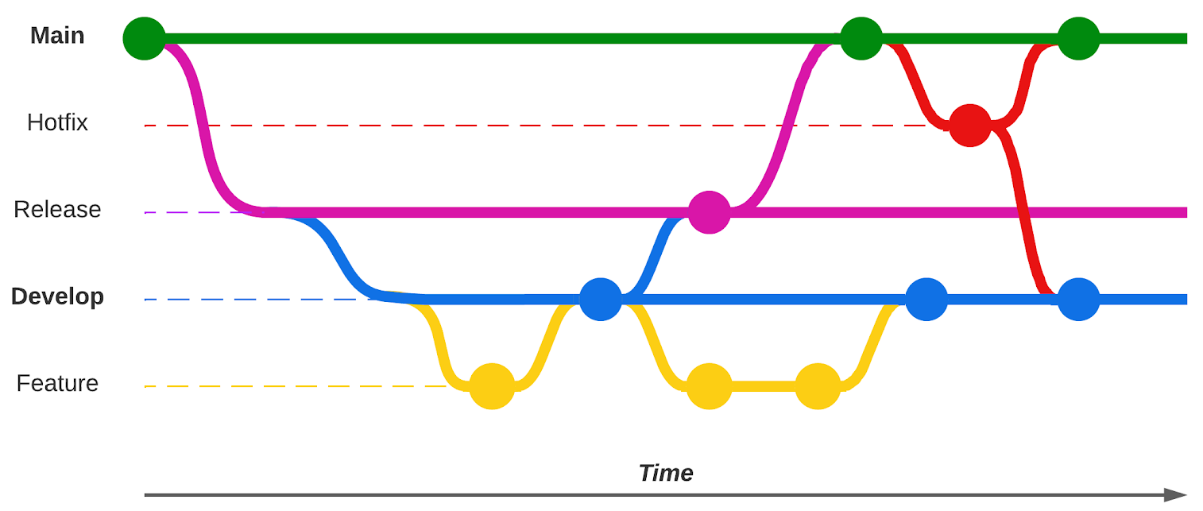
3-8. Figure: Git branches strategy
To carry out all these automations, a Jenkins pipeline has been used. First, a multibranch project was created in Jenkins. Here, it was configured to listen for pushes to the remote repository on the master branch and on the develop branch. Next, the Jenkinsfile file was created, located in the project folder. The Jenkinsfile is divided into stages, which run PowerShell scripts that execute different commands to perform various tasks. The Jenkinsfile is divided into 6 stages: the build, the Java tests, the Python tests, the Java SonarQube scan, the Python SonarQube scan and the publish. This last stage is only executed when the push is to master, because a compressed folder of the project is created and uploaded to the virtual machine in Cloud, ready to be executed, which is only necessary when a new version of the product is completed in the main branch.

Conclusions
Following the development of the project, a number of conclusions have been drawn in relation to the objectives achieved. To this end, first of all, it will be explained how the project actually have gone comparing it to the initial planning. In addition, it will be also justified whether the problem to be resolved by this draft is answered or not. The following will explain whether or not the objectives initially set have been achieved, specifying how those achieved have been achieved. Finally, the actual impact on the SDGs will be assessed by comparing them with those initially proposed and presenting the conclusions drawn from them.

Planification’s conclusions
To start with the end of the document, in this section some conclusions will be made to determine how the project has gone. As explained above, the Kanban methodology was used throughout the project. After the closing of the project, all the members of the group concluded that the use of this methodology has been beneficial for the result of the final product and for the efficiency of the day-to-day work. By having well-defined work policies and PBIs from the beginning, when a member had just made a PBI, they knew exactly which PBI or what work they had to do at that moment, which is why it is believed that productivity in working hours has increased.
The daily meetings and the weekly updates have been done rigorously every day, and the group in general believes that the fact of doing them has been positive for everyone, as they are a great help to have control of what each one has done each day and to be clear about what each member of the group has to do. In addition, when the weekly updates were made, the group work policies were changed several times with the aim of improving efficiency and the development of the work. All the meeting hold during the project’s development can be seen in 2. Annex: Meetings' minutes.
At the beginning of the work, when the project was being planned and organised, a Gantt chart was drawn up with different activities that each member had to do and in what order they had to be done. Now that the project is finished, it will be checked if what was initially planned has been fulfilled.
In the planning that was done at the beginning, the works that lay the foundations of the project, it was agreed to be done at the beginning of the project in order to have a clear basis for the rest of the projects. Comparing it with the current Gantt, that fact has been fully respected, and those activities have been done to the letter as it can be seen in the current Gantt. However, from then on, as the project progressed, several activities had to be postponed and extended due to problems or unforeseen events during the duration of the project, but in the end most of the activities planned at the beginning of the project were successfully done. The only activity that has not even been started, due to lack of time, is the forum recommendation system that was planned in the initial Gantt for the last days of the project. The rest of the activities planned have been carried out, even if some of them have been out of date.

Problem’s solving
Once the project’s planification conclusions have been taken, it will be explained whether the problem that was raised at the beginning of this report has been solved or not. At the beginning of this report, it was stated that 98% of people who invest in the stock market lose money and that, in general, a big amount of the public has little knowledge about the stock market. In addition, it was stated that the main problem with the stock market is that there are too many external factors that affect the stock market and that the human being, being a rational being and not a machine, is not able to analyse them all in real time, as by the time they have been analysed they have been changed again.
After the completion of the project, it is believed that the first problem has been partially solved, because even if it is impossible that nobody loses money on the stock market, mainly because it is not possible, it has contributed the users to make better investments. Regarding the second problem, it has been concluded that it has been solved. By using the product that has been created, people have the possibility to learn how the stock market works and how external factors that may often seem insignificant can change the course of the stock market’s value. Finally, a satisfactory solution has been found to the problem of humans and their inability to analyse thousands of pieces of data, as a machine learning model has been created that is capable of analysing and responding to tens of thousands of pieces of data. In addition, by using the previously explained scraping method, the database is updated every day, so that the new predictions have the updated data.

Objectives achievements
Once the main objective has been justified, an assessment of the achievement of the various objectives contained in the project will be carried out. Although many of the objectives initially defined in the project have been achieved, there are others that have not been achieved in the prototype and have remained in the form of future lines. Those objectives were the indicator of the project's success or failure. Those objectives were as follows: to develop a robust AI model to make stock market predictions, to minimise investment risks through a comprehensive risk assessment, to help users understand the stock market, to create a forum for users, and to develop a user recommendation system.
Among the objectives that have been achieved are to help users understand the stock market, as a search section has been created where the user can see the chronology of the different external factors and the changes they have produced in the stock market. In addition, forums have been created for users so that all users of the platform can talk to each other and solve all the questions they may have or discuss about the stock market. Another of the objectives achieved has been to minimise investment risks by means of a comprehensive risk assessment, as the involvement of more than twenty external factors in the IBEX has been evaluated, and the user can see which factors have the greatest influence on the stock market by means of graphs.
One of the objectives that has been decided for the future is to develop a recommendation system for the user, as it has been decided to not to implement it in this first version of the product to give more time to other objectives more significant. Apart from that, the objective of developing a robust AI model to make predictions has been achieved, but not with the success that was expected at the beginning. A coefficient of determination of 0.6 was set as a target, but it has not been achieved. In the table below it can be seen which objectives have been achieved and which one are in process of achieving (4-1. Table: Objectives achieved and in process of achieving).
4-1. Table: Objectives achieved and in process of achieving
OBJECTIVES ACHIEVED | OBJECTIVES IN PROCESS OF ACHIEVING
Develop a robust AI model for stock market predictions | Achieve a minimum value of the coefficient of determination (R²) of 0.6
Minimise investment risks through comprehensive risk assessment | Elaborate a recommendation system for the user
Help users understand the stock market
Creating forums for users to discuss

SDG impact evaluation
On September 25, 2015, world leaders set themselves 17 global goals to eradicate poverty, protect the planet, and ensure prosperity within a new 2030 agenda for sustainable development. Each objective has specific objectives to be achieved over the next 15 years. Therefore, in order to achieve these objectives, this project aims to achieve a number of these objectives in order to promote many of the achievements that are intended to be eradicated or promoted and to contribute to the overall objective set for 2030. This project has therefore sought to influence as many of these objectives as possible ().
To end the section on conclusions, a reminder will be made of the Sustainable Development Goals that were said to be met at the beginning of the project and it will be seen whether they were met or not. At the beginning of the project development, it was said that the finished project could meet the following goals: Quality Education, Decent Work and Economic Growth and Industry, Innovation, and Infrastructure. At the conclusion of the project, it is believed that the 3 sustainable development objectives that were proposed have been met.
In the Quality Education objective, it is believed that it has been fulfilled because on the web page that has been created there is a whole section that simply serves to explain how external factors influence the stock market and how each of them influences it. In the same way, a financially well-educated society is always positive for the state and the economy of a country, as more entrepreneurs and companies can emerge, which is why the objective of Decent Work and Economic Growth is fulfilled. Finally, the objective of Industry, Innovation and Infrastructure is fulfilled because different cutting-edge technologies have been used to make this project, such as the use of machine learning or web technology, which is why it has contributed to innovation and technological development.

Future lines
With regard to the future lines of the project, it should be noted that the product obtained is still only a prototype. A number of functionalities and features that the product must have haven’t been yet implemented, but these will be added to the final product. This part will describe the improvements and supplements that would be applied to the final product in the future.

Improvements
The product is a prototype and is still under development. There are things that are not yet included in this initial version. However, it is planned that the final product will incorporate all the features that will be explained below. With these features the product will be more complete, and users will be able to enjoy it more. One of the new things that will be implemented will be to make the web more secure than it is, that is to say, protecting in a better way the web from suffering attacks from other people or even the theft of information. In addition, the web will be designed with a server and not with Node-Red tool, using it only for connections between servers instead of doing the whole frontend there. Finally, as for the prediction made by the model, it could be improved by adding more external factors and thus apply almost all the factors that affect the stock market price, resulting in a better prediction.

Supplements
To enhance the app in the future, the integration of key features that will improve the user’s experience is planned. First, the possibility of allowing users to invest directly in the stock market via the app will be explored, providing a one-stop solution for managing their investments. In addition, it is expected to extend the prediction functionalities, offering forecasts at longer intervals, such as one week or one month, to provide a more comprehensive and longer-term view of market trends. In line with user interaction, a forum recommendation system is planned. This functionality will allow users to discover and participate in relevant market discussions, facilitating an exchange of knowledge and opinions that will complement the existing simulation and forum. Together, these additions will strengthen the application as a complete tool for understanding, simulating, and participating in the financial world.

Bibliography
BasuMallick, Chiradeep. Spice Works. 20 July 2022. https://www.spiceworks.com/tech/devops/articles/what-is-jenkins/.
Bigelow, Stephen J. Tech Target. March 2022. https://www.techtarget.com/searchcloudcomputing/definition/Google-Cloud-Platform.
G., Domantas. Hostinger. 19 January 2024. https://www.hostinger.com/tutorials/what-is-mysql.
Hernandez, Joe. NPR. 15 September 2023. https://www.npr.org/2023/09/15/1199321274/lehman-brothers-collapse-2008-mortgages.
Java TM. Java. 2023. https://www.java.com/en/download/help/whatis_java.html.
Kumar, Rajesh. Dev Ops School. 5 March 2022. https://www.devopsschool.com/blog/what-is-sonarqube-and-how-it-works-an-overview-and-its-use-cases/.
Lea, Rodger. Node Red guide. 1 January 2023. https://noderedguide.com/nr-lecture-1/.
MDN contributors. MDN. 1 January 2024. https://developer.mozilla.org/en-US/docs/Learn/JavaScript/First_steps/What_is_JavaScript.
Nair, Anurag. We are community. 2021 March 12. https://wearecommunity.io/communities/india-java-user-group/articles/891.
Python. Python. n.d. https://www.python.org/doc/essays/blurb/.
Sancho, Jesus. La Vanguardia. 8 February 2011. https://www.lavanguardia.com/economia/20110208/54112093149/jose-a-madrigal-el-98-de-los-que-empiezan-a-invertir-en-bolsa-pierde-dinero.html.
W3 Schools. W3 Schools. n.d. https://www.w3schools.com/html/html_intro.asp.
—. W3 Schools. n.d. https://www.w3schools.com/css/css_intro.asp.

Annexes
1. Annex: Project's initial planning

2. Annex: Meetings' minutes

